**/*TE CMPN A-27*/**

**Expt : 6**

**Aim :** To create Internal and External DTD

**Internal DTD:**

<?xml version="1.0"?>

<!DOCTYPE employeetab[

<!ELEMENT employeetab (employee*)>

<!ELEMENT employee (E_Name,E_Add+,E_Phone*,Salary?)>

<!ATTLIST employee eid CDATA #REQUIRED>

<!ELEMENT E_Name (F_Name,L_Name)>

<!ELEMENT F_Name (#PCDATA)>

<!ELEMENT L_Name (#PCDATA)>

<!ELEMENT E_Add (Street,City,Pin)>

<!ELEMENT Street (#PCDATA)>

<!ELEMENT City (#PCDATA)>

<!ELEMENT Pin (#PCDATA)>

<!ELEMENT E_Phone (#PCDATA)>

<!ELEMENT Salary (#PCDATA)>

]>

<employeetab>

<employee eid="E001">

<F_Name>Flevia</F_Name>

<L_Name>Fargose</L_Name>

<Street>MG Road</Street>

<City>Vasai</City>

<Pin>401201</Pin>

<E_Phone>9637142573</E_Phone>

<Salary>35,000</Salary>

</employee>

<employee eid="E002">

<F_Name>Glancy</F_Name>

<L_Name>Rodrigues</L_Name>

<Street>PS Road</Street>

<City>Virar</City>

<Pin>401203</Pin>

<E_Phone>7276820232</E_Phone>

<Salary>30,000</Salary>

</employee>

<employee eid="E003">

<F_Name>Stalen</F_Name>

<L_Name>Rumao</L_Name>

<Street>RN Street</Street>

<City>Borivali</City>

<Pin>400200</Pin>

<E_Phone>8983436824</E_Phone>

<Salary>30,000</Salary>

</employee>

</employeetab>

**/*OUTPUT:**

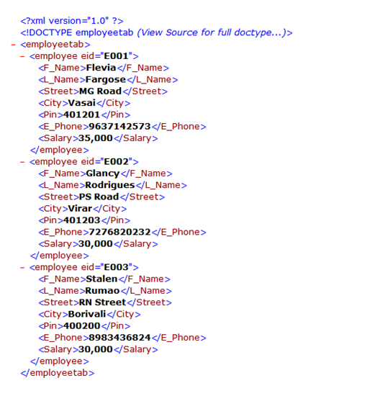

**External DTD:**

**DTD File**

<?xml version="1.0"?>

<!ELEMENT employeetab (employee*)>

<!ELEMENT employee (E_Name,E_Add+,E_Phone*,Salary?)>

<!ATTLIST employee eid CDATA #REQUIRED>

<!ELEMENT E_Name (F_Name,L_Name)>

<!ELEMENT F_Name (#PCDATA)>

<!ELEMENT L_Name (#PCDATA)>

<!ELEMENT E_Add (Street,City,Pin)>

<!ELEMENT Street (#PCDATA)>

<!ELEMENT City (#PCDATA)>

<!ELEMENT Pin (#PCDATA)>

<!ELEMENT E_Phone (#PCDATA)>

<!ELEMENT Salary (#PCDATA)>

**Xml File**

<?xml version="1.0"?>

<!DOCTYPE employeetab SYSTEM "external.dtd">

<employeetab>

<employee eid="E001">

<F_Name>Flevia</F_Name>

<L_Name>Fargose</L_Name>

<Street>MG Road</Street>

<City>Vasai</City>

<Pin>401201</Pin>

<E_Phone>9637142573</E_Phone>

<Salary>35,000</Salary>

</employee>

<employee eid="E002">

<F_Name>Glancy</F_Name>

<L_Name>Rodrigues</L_Name>

<Street>PS Road</Street>

<City>Virar</City>

<Pin>401203</Pin>

<E_Phone>7276820232</E_Phone>

<Salary>30,000</Salary>

</employee>

<employee eid="E003">

<F_Name>Stalen</F_Name>

<L_Name>Rumao</L_Name>

<Street>RN Street</Street>

<City>Borivali</City>

<Pin>400200</Pin>

<E_Phone>8983436824</E_Phone>

<Salary>30,000</Salary>

</employee>

</employeetab>

**/*OUTPUT:**



